**WEEK 7**

**Module 10 – Single Page Application framework – React**

**17. ReactJS-HOL**

**CODE:**

**src/Getuser.js**

import React, { Component } from 'react';

import './index.css';

class Getuser extends Component {

constructor(props) {

super(props);

this.state = {

person: null,

loading: true

};

}

async componentDidMount() {

const url = "https://api.randomuser.me/";

const response = await fetch(url);

const data = await response.json();

this.setState({

person: data.results[0],

loading: false

});

}

render() {

const { person, loading } = this.state;

if (loading) {

return <h2>Loading...</h2>;

}

return (

<div className="user-container">

<h2>User info from random API</h2>

<h3>{person.name.title} {person.name.first} {person.name.last}</h3>

<img src={person.picture.large} alt="User" />

</div>

);

}

}

export default Getuser;

**src/App.js**

import React from 'react';

import Getuser from './Getuser';

function App() {

return (

<div className="App">

<Getuser />

</div>

);

}

export default App;

**src/index.css**

body {

font-family: Arial, sans-serif;

background-color: #f5f5f5;

margin: 0;

padding: 0;

}

.App {

display: flex;

justify-content: center;

align-items: center;

height: 50vh;

}

.user-container {

background-color: white;

padding: 30px;

border-radius: 8px;

text-align: center;

box-shadow: 0 0 10px rgba(0, 0, 0, 0.1);

}

.user-container h2 {

margin-bottom: 20px;

}

.user-container img {

width: 150px;

border-radius: 10%;

}

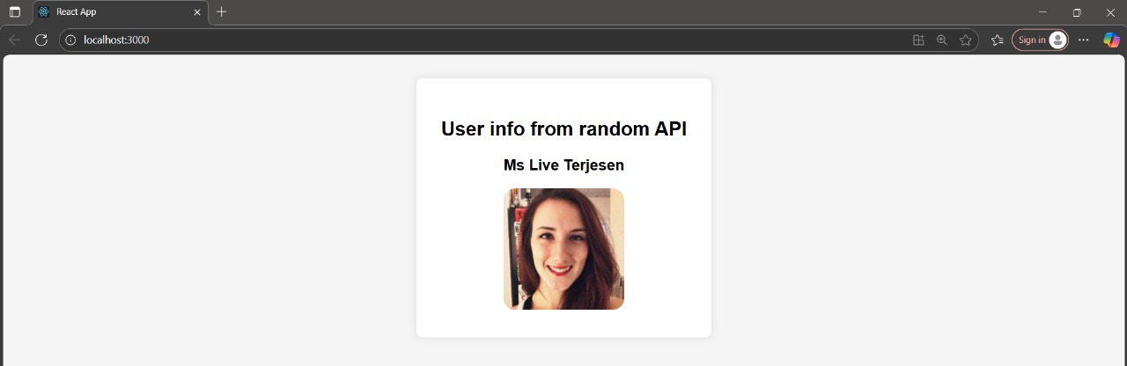**OUTPUT:**